Types of music recommendation

-song

-playlist

-album

-artists

Techniques for music recommendation

-popularity

-content based filtering

-collaborative filtering (spotify)

Spotify recommendation architecture

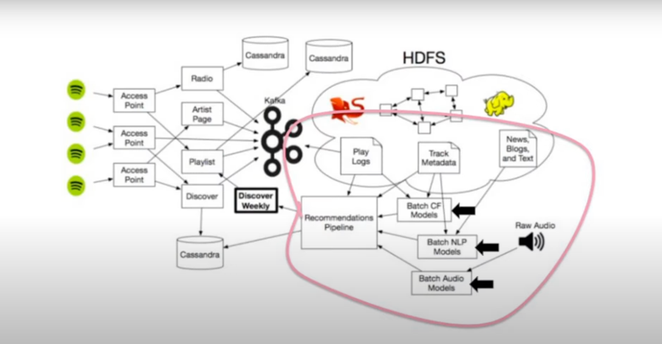

User item matrix

